GARAGE - CAR SERVICE MANAGEMENT SYSTEM

PROJECT REPORT SUBMITTED IN PARTIAL FULFILMENT OF THE REQUIREMENTS FOR THE AWARD OF

BACHELOR OF COMPUTER APPLICATIONS

To

MARIAN COLLEGE KUTTIKKANAM [AUTONOMOUS]

Affiliated to

MAHATMA GANDHI UNIVERSITY, KOTTAYAM

By
NAVEEN E SAJI (Reg.No:23UBC243) VIVEK BENNY (Reg.No:23UBC259)

Guided By

Ms. ROSHINI RAJENDRAN



DEPARTMENT OF COMPUTER APPLICATIONS MARIAN COLLEGE KUTTIKKANAM (AUTONOMOUS)

PEERMADE – 685531

OCTOBER, 2025
DECLARATION

We, NAVEEN E SAJI [Reg.no 23UBC243], VIVEK BENNY
[Reg.no 23UBC259] certify that the Mini project report entitled “GARAGE- CAR SERVICE MANAGEMENT SYSTEM” is an authentic work carried out by us at Marian College Kuttikkanam(Autonomous). The matter embodied in this project work has not been submitted elsewhere for the award of any degree or diploma to the best of our knowledge and belief.

Signature of the Students:

NAVEEN E SAJI

VIVEK BENNY

Date:

BONAFIDE CERTIFICATE

This is to certify that this project work entitled ““GARAGE- CAR SERVICE MANAGEMENT SYSTEM” is a bonafide record of work done by Mr. NAVEEN E SAJI [Reg.no 23UBC243], Mr. VIVEK BENNY [Reg.no 23UBC259] at Marian College Kuttikkanam (Autonomous) in partial fulfilment for the award of the Degree of Bachelor of Computer Applications of Mahatma Gandhi University, Kottayam.
This work has not been submitted elsewhere for the award of any degree to the best of our knowledge.

Head of the Department Internal Guide

Dr Rajimol A Ms. Roshini Rajendran

Dept. of Computer Applications Dept. of Computer Applications

Marian College Kuttikkanam Marian College Kuttikkanam

Peermade – 685531 Peermade - 685531

Submitted for the Viva-Voice Examination held on

DEPARTMENT SEAL

EXTERNAL EXAMINER

ACKNOWLEDGEMENT

“Gratitude is a feeling which is more eloquent than words, more silent than silence.” In undertaking this project, we needed the direction, assistance and cooperation of various individuals and organizations, which is received in abundance with grace of God, without their unconstrained support, the project could not have been completed. If words are considered as the symbol of approval and token of acknowledgement, then let the following words play the heralding role of expressing our gratitude.
We wish to acknowledge our sincere gratitude to our Manager, Rev.Fr. Boby Alex Mannamplackal and Dr Ajimon George, Principal Marian College Kuttikkanam (Autonomous), for all their efforts and administration in educating us in their premier institution.
We extend our gratitude to Dr Rajimol A, Head of the Department of Computer Application,who is a constant source of inspiration and whose advice helped us to complete this project successfully.We express our deep sense of gratitude to our internal project guide, Ms Roshini Rajendran for her profound guidance for the successful completion of this project. With greatenthusiasm we express our gratitude to all the faculty members of Department of ComputerApplications for their timely help and support.Finally, we express our deep appreciation to all our friends and family members for the moral support and encouragement they have given to complete this project successfully.

Naveen E Saji,Vivek Benny

ABSTRACT

ABSTRACT

The project named " GARAGE - Car Service Management System" is a web-
based platform for managing automotive service operations efficiently. The system streamlines
car service processes, making vehicle maintenance and repair services more accessible and
convenient for both customers and service providers. The platform offers essential tools for
managing bookings, vehicle information, service scheduling, and staff coordination in the digital
era. The system mainly consists of three modules: Users, Staff, and Admins. Users can book
services, track vehicle maintenance history, and communicate with service staff. They can view
detailed service information, schedule appointments with mechanics, and manage their vehicle
profiles. Staff members can manage their work schedules, apply for leave, and communicate with
customers.

Admins can oversee all operations, manage services, staff, and customer bookings. Admins have the
ability to ensure that service appointments are scheduled efficiently, manage mechanic assignments,
and monitor service quality. Additionally, the platform supports secure user authentication, real-time
notifications, and comprehensive reporting to keep all stakeholders informed about service status
and operations.

The platform uses HTML, CSS, and JavaScript for the front end, providing an intuitive user
interface. The back end, developed with PHP and MySQL, ensures robust data management and
seamless functionality for automotive service operations.

TABLE OF CONTENTS
TITLE | PAGE NUMBER
1.INTRODUCTION | 10
1.1 ABOUT THE PROJECT | 10
1.2 EXISTING SYSTEM | 10
1.3 PROPOSED SYSTEM | 11
2. SYSTEM ANALYSIS | 13
2.1 PROBLEM DEFINITION | 13
2.2 FEASIBILITY ANALYSIS | 13
2.3 RECOMMENDED IMPLEMENTATIONS | 14
3. SOFTWARE REQUIREMENT SPECIFICATION | 17
3.1 INTRODUCTION | 17
3.2 PURPOSE | 17
3.3 SCOPE | 18
3.4 TECHNICAL OVERVIEW | 18
3.5 FUNCTIONAL REQUIREMENTS | 18
3.6 NON-FUNCTIONAL REQUIREMENTS | 20
3.7 STATED REQUIREMENTS | 21
3.8 EXTERNAL INTERFACE REQUIREMENTS | 23
4. SYSTEM DESIGN | 27
4.1 INTRODUCTION | 27
4.2 DESIGN METHODOLOGY | 28
4.3 SYSTEM ARCHITECTURE AND PROCESS FLOW | 32
4.4 MODULE DETAILS | 45
4.5 PERFORMANCE CONSIDERATIONS | 46
4.6 SECURITY CONSIDERATIONS | 46
4.7 TABLE DESIGN | 46
5.CODING | 52
5.1 INTRODUCTION | 52
5.2 SELECTION OF SOFTWARE | 52
5.3 CODING PHASE | 53

- TESTING 55
  - INTRODUCTION 55
  - TESTING 55
  - TESTING METHODS 56
  - IMPLEMENTATION 59
- MAINTENANCE AND ENHANCEMENT 62
  - MAINTENANCE 62
  - ENHANCEMENT 62
- CONCLUSION 65

INTRODUCTION

- INTRODUCTION

  - ABOUT THE PROJECT

The Car Service Management System is a digital platform designed to streamline automotive
service operations and enhance customer experience. It provides a comprehensive suite of features
for customers to book services, track vehicle maintenance, and communicate with service staff. The website's user-friendly interface ensures a smooth navigation experience, allowing users to easily view service details, schedule appointments, and manage their vehicle information with automotive professionals for support and maintenance.

THE PURPOSE AND SCOPE

The primary purpose of the Car Service Management System Project is to establish an
efficient and convenient online platform for automotive service operations. The project
aims to provide a centralized hub where customers can book services, track vehicle maintenance,
communicate with mechanics, and manage their automotive needs seamlessly. The scope of the project includes:
➢ Enabling customers to book various automotive services online.
➢ Empowering users to manage vehicle information and service history with detailed records.
➢ Facilitating customer-staff communication through integrated messaging system.
➢ Implementing admin functionalities to manage services, staff scheduling, mechanic assignments, and customer support.

  - EXISTING SYSTEM

In the current scenario, accessing automotive service solutions often involves fragmented
and time-consuming manual processes. Customers typically rely on phone calls, physical visits,
and limited service tracking methods. This manual approach can lead to inefficiencies, scheduling
conflicts, delays, and limited visibility into service progress and vehicle maintenance history.

  - PROPOSED SYSTEM

The main objective of the proposed Celestia Interior & Exterior Design Website is to eliminate the limitations of the existing manual system and make it more user-friendly. Most of the
limitations of the current system can be overcome by the proposed system. Speed and accuracy are the main advantages of the proposed system, with no redundancy of data. The proposed software requires fewer resources to manage the entire design platform. Since all details are stored digitally, searching time is reduced. Information can be more secure because computer systems provide better data security. The proposed system eliminates many drawbacks of the existing system and enhances data security, user experience, and operational efficiency.

SYSTEM ANALYSIS

2.SYSTEM ANALYSIS

  - PROBLEM DEFINITION

The current system does not effectively utilize digital solutions for automotive service management needs, and lacks refinement. Even when records are kept digitally, they are often managed inefficiently and are not integrated with modern web technologies. This makes it difficult to handle various aspects like customer interactions, service scheduling, mechanic assignments, and inventory management efficiently. Much of the record-keeping and appointment scheduling are still done manually, leading to errors, double bookings, and delays. To overcome these limitations, the Car Service Management System is proposed.

2.1.1 ADVANTAGES OF PROPOSED SYSTEM

- Avoids Redundancy: The system uses various types of validation to eliminate Redundancy , enhancing overall operational efficiency.
- Quick Access and Processing: The proposed system offers faster access and processing,making it more efficient than the existing manual system.
- Time Efficiency: The new automated system significantly reduces time consumption compared to the existing manual appointment and service management system.
- Reduces Paperwork: The system minimizes the need for paperwork, streamlining automotive service operations.
- Provides Accurate Information: The system ensures the accuracy of service information , vehicle records, and scheduling, improving reliability and decision-making.

  - FEASIBILITY ANALYSIS

Feasibility study is a test of a system proposal according to its workability, ability to meet user needs and effective use of resources. The objective of feasibility is not to solve the problem but to acquire a sense of its scope. The main aim of the feasibility study is to test the technical, social
and economic feasibility of the system. The feasibility study can be classified into the following
categories:

➢ Operational Feasibility
➢ Technical Feasibility
➢ Economic Feasibility

OPERATIONAL FEASIBILITY

The proposed system offers user friendliness combined with greater processing speed for automotive service operations. Therefore, the work done can be reduced significantly. Since the processing speed is very high compared with manual system a lot of time can be saved in servicescheduling and management. The workload is reduced and this system requires only small amount of work from admin who manages the whole system, along with staff members who can efficientlymanage theirschedules and customer interactions.Hence,thisprojectisoperationally feasible.

TECHNICAL FEASIBILITY

Technical feasibility deals with hardware as well as software requirements and to what extend it can support the proposed system. The hardware required is a computer system with internet connectivity and software includes PHP, MySQL, and web technologies. If thenecessary requirements are made available with the system, then the proposed system is said to be technically feasible.

ECONOMIC FEASIBILITY

Economic feasibility is an important factor. Since the existing system is manual, the feasibility for wrong data entry is higher and consumes a lot of time and can occur errors in service scheduling and customer management. But the proposed system aims at processing of automotive service information efficiently, thus saving time and reducing operational costs. The new system needs only a computer system with internet connectivity which is already available therefore the cost is negligible. Proposed system uses validation checks so there are minimal errors. Even though an initial investment has to be made on the software and the hardware aspects, the proposed system aims at processing of service information efficiently. Thus, the benefits acquired out of the system are sufficient enough for the project to be undertaken. So, the proposed system is economically feasible.

  - RECOMMENDED IMPLEMENTATIONS

Two principle sources of data are:

➢ Written documents
➢ Data from persons who are involved in the operation of the automotive service system under study.
The different fact-finding techniques are:

➢ Questionnaires
➢ Personal Interviews
➢ Observations

Questionnaires

Questionnaires are best methods to probe data out of the customers and service staff. In this case, questionnaires were used to collect feedback from existing customers about their service experience and expectations from an automated system.

Personal Interviews

Personal interviews are the best way to gather facts. This was the primary source of fact finding used for this project. The service center owner, mechanics, and staff were interviewed and data collected. They were asked how the service operations and record keeping happened under the existing system. And suggestions were taken on what they wanted to add in this automated system.Almost all their suggestions were integrated into this project.

Observations

A person can understand a lot about a system just by observing it. By being a bystander and observing how a day passes in the automotive service center helped to kick off this project. Using this method resulted in a better understanding of the workings of the service operations and what to do to make this a comprehensive web application. Observing the current system, one can understand that a lot of paperwork and manual coordination is involved in the service scheduling and customer management area. The way in which the records are kept gives an idea for a strong database model.

SOFTWARE REQUIREMENT SPECIFICATIONS

- SOFTWARE REQUIREMENT SPECIFICATION

  - INTRODUCTION

Requirements specification is the starting step for the development activities. It is currently one of the weak areas of software engineering. During requirement specification, the goal is to produce a document of the client's requirements. This document forms the basis of development and software validation. The basic reason for the difficulty in software requirements specification comes from the fact that there are three interested parties- the client, the end users and the software developer.

  - PURPOSE

The origin of most software systems is in the need of a client, who either wants to automate an existing manual system or desires a new software system. The software system itself is created by the developer. Finally, the completed system will be used by the end users. Thus, there are three major parties interested in a new system: the client, the users and the developer. A basic purpose of software requirements specification is to bridge the communication gap. SRS is the
medium through which the client and user needs are accurately specified. Indeed, SRS forms the basis of software development. A good SRS should satisfy all the parties, something very hard to achieve, and involves trade-offs and persuasion.
Another important purpose of developing an SRS is helping the clients understand their own needs. Advantages are:

An SRS establishes the basis for agreement between the client and the supplier on what the software product will do An SRS provides a reference for validation of the final product a high-quality SRS is a prerequisite to high-quality software. A high-quality SRS reduces the development cost.

  - SCOPE

SYSTEM STATEMENT OF SCOPE

The Car Service Management System was developed to provide a platform for managing automotive service operations, scheduling appointments, and tracking vehicle maintenance. The system further offers features such as service booking, staff management, mechanic assignment, and customer communication. Reports can be generated to retrieve operational data.

  - TECHNICAL OVERVIEW

USER CHARACTERISTICS

The system can be accessed by three types of users: Admin, Staff, and Customers. Admins have access to the complete admin dashboard, staff have access to their work management interface, while customers have access to the booking system and service tracking. The admin and staff functionalities are invisible to customers.

  - FUNCTIONAL REQUIREMENTS

The functional requirements of this website are as follows:

User Management:
User Registration Process: Customers provide essential details like name,email,password, and phone number.
User Authentication:
➢ Users log in by entering their registered email and password.
➢ The system verifies credentials against stored data to allow access.
➢ Users can securely log out, ending their active sessions to prevent unauthorized
access.
Vehicle Management:
➢ Customers can add and manage their vehicle information including type, brand, model,
registration number, and year.
➢ Multiple vehicles can be registered under one customer account.

Service Management:
➢ Customers can browse available automotive services with detailed descriptions and pricing.
➢ Customers can book services by selecting preferred date, time slot, and required services.

Booking Management:
➢ Customers can schedule service appointments with preferred mechanics.
➢ Admins can manage and oversee service bookings, ensuring efficient scheduling.
➢ Mechanics can be assigned to specific bookings based on their expertise and availability.

Staff Management:
➢ Staff members can apply for leave by specifying dates and reasons.
➢ Admins can approve or reject leave applications.
➢ Staff schedules can be managed efficiently.

Mechanic Management:
➢ Admins can add new mechanics with details like name, age, profession, and contact information.
➢ Mechanic availability and assignment status can be tracked.
➢ Mechanics can be assigned to specific service types based on their expertise.

Communication System:
➢ Customers can send messages to staff for inquiries or support.
➢ Staff can respond to customer messages through the system.
➢ Message history is maintained for reference.

Admin Dashboard:
➢ Admins can oversee all bookings and service operations.
➢ Admins can manage services, staff, mechanics, and customer accounts.
➢ Comprehensive reporting and analytics for business insights.

  - NON-FUNCTIONAL REQUIREMENTS

The non-functional requirements of this website are as follows:

Usability:
➢ Intuitive and user-friendly interface for all user types.
➢ Comprehensive service booking features and clear navigation.
Reliability:
➢ System performs reliably in 95% of use cases monthly.
➢ Ensure consistent and accurate data processing for service operations.
Availability:
➢ Accessible globally 24/7 for customer convenience.
➢ Backup and recovery mechanisms to restore service within an hour of a failure.
Security:
➢ Hourly backups of the database.
➢ Secure handling of customer and vehicle data to protect privacy and prevent unauthorized access.
Performance:
➢ Quick response times and minimal latency for booking operations.
➢ Efficient handling of large volumes of service data and customer information.
Scalability:
➢ Capable of supporting a growing number of customers, vehicles, and service bookings.
➢ Modular architecture to facilitate easy expansion of services.
Maintainability:
➢ Codebase should be well-documented and modular for ease of updates and bug fixes.
➢ Regular maintenance schedules to ensure system health and performance.

  - STATED REQUIREMENTS

GENERAL REQUIREMENTS

The system has 8 functional modules divided between admin, staff, and customers.

Login
➢ Only registered users (customers, staff, and admins) can log in to the system to avail the services.
➢ The registered users use their email and password to log in.
➢ The user email should always be a valid email address.
➢ The password can contain both uppercase and lowercase alphabetic characters,
numbers, and special characters.
➢ Admins will be redirected to the admin panel when logging in with admin credentials.
➢ Staff will be directed to the staff dashboard when logging in with staff credentials.
➢ Customers will be directed to the main service booking page when login is successful.
Sign Up
➢ New customers need to register in order to use the platform's services.
➢ This includes several fields:
▪ Name
▪ Email Address
▪ Password
▪ Phone Number
Admin Panel
The admin panel contains different admin processes such as:
▪ Managing service bookings and assignments
▪ Managing staff and mechanics
▪ Managing services and pricing
▪ Viewing reports and analytics
Staff Dashboard
The staff dashboard allows staff members to:
▪ View assigned work schedules
▪ Apply for leave
▪ Communicate with customers
▪ Update service status
Service Booking
➢ Customers can browse and book various automotive services.
➢ Service details include descriptions, pricing, and estimated time.
Vehicle Management
➢ Customers can add multiple vehicles to their profile.
➢ Vehicle information includes type, brand, model, registration number, and year.
Mechanic Assignment
➢ Admins can assign mechanics to specific bookings based on expertise.
➢ Mechanic availability and status can be tracked.
Communication System
➢ Customers can send messages to staff for support.
➢ Staff can respond to customer inquiries.

INPUTS

The Car Service platform will take various inputs to provide its services:
Customer Registration:
➢ Name
➢ Email Address
➢ Password
➢ Phone Number
Login:
➢ Email Address
➢ Password
Vehicle Information:
➢ Vehicle Type (SUV, Sedan, Hatchback, etc.)
➢ Brand
➢ Model
➢ Registration Number
➢ Year
Service Booking:
➢ Selected Services
➢ Preferred Appointment Date
➢ Time Slot
➢ Vehicle Selection
Staff Leave Application:
➢ Leave Reason
➢ From Date
➢ To Date
Mechanic Information:
➢ Name, Age, Profession
➢ Contact Details
➢ Specialization

PROCESSING

The system will perform the following key processing tasks:

Data Validation:
➢ Validate email format and password complexity.
➢ Ensure required fields are not empty.
➢ Validate vehicle registration number format.
Service and Booking Management:
➢ Customers book services and manage appointments.
➢ Admins oversee bookings and assign mechanics.
➢ Service status tracking and updates.
Staff and Mechanic Management:
➢ Leave application processing and approval.
➢ Mechanic assignment based on availability and expertise.
➢ Work schedule management.
Communication Processing:
➢ Message routing between customers and staff.
➢ Response tracking and history maintenance.

OUTPUTS

The system produces the following outputs:

Service Information:

➢ Service Name, Description, Price

➢ Estimated Time and Requirements

Booking Confirmation:

➢ Booking details with assigned mechanic

➢ Appointment date and time confirmation

Vehicle Details:

➢ Complete vehicle information and service history

Staff Information:

➢ Leave status, work assignments

➢ Communication logs

Reports:

➢ Service analytics and business reports

➢ Customer and revenue insights

  - EXTERNAL INTERFACE REQUIREMENTS

USER INTERFACES

All user interfaces will be GUI interfaces, designed for ease of use and high functionality. The interfaces will have a pleasing appearance and intuitive design.

Design and Appearance:

➢ The interface will use suitable design elements and pleasing colors to create a comfortable and attractive environment for users.

➢ Consistent design themes will be maintained across all pages.

Usability Components:

➢ Textboxes, combo boxes, and buttons will be used to facilitate easy data entry.

➢ Clear labels and instructions will be provided for all input fields.

➢ Intuitive navigation elements will help users move seamlessly through the

platform.

Responsive Design:

The user interface will be responsive to ensure usability across various devices,

including desktops, tablets, and smartphones.

HARDWARE INTERFACES

The system needs a computer or any other smart devices with network availability
to access the web application. No other external hardware is required.

Hardware Specification

Processor: Intel Pentium or higher
RAM: 256 MB or higher
Hard Disk Drive: 100 MB required on disk
Keyboard: Standard QWERTY keyboard

Implementation Specification

Operating System: Windows OS

SOFTWARE INTERFACES

Software Specification

- Operating System: Windows 11
- DBMS: MySQL
- Tool Used: PHP

SYSTEM DESIGN

- SYSTEM DESIGN

  - INTRODUCTION

The design phase aims to develop a solution for the problems identified during the analysis phase.This phase marks the transition from understanding the problem to creating a solution. System design details the equired features and operations, including screen layouts, business rules,process diagrams, pseudocode, and other relevant documentation.

During this phase, the overall structure and specifics of the software are defined. This includes determining the number of tiers needed for the architecture, designing inputs and outputs, and establishing database and data structure designs. Proper analysis and design are critical to the development cycle since errors in this phase can be costly to fix later. Therefore, careful attention is given during the design phase.

The logical framework of the product and its physical attributes are outlined during this stage.The operating environment is set up, and key resources are identified. Any element that requires user input or approval must be documented and reviewed by the user. The physical aspects of the system are specified, and a detailed design is prepared.

Subsystems identified during design are used to create a detailed system structure. Each subsystem is divided into one or more design units or modules, and detailed logic specifications are created for each module. The module logic is typically described in a high-level design language, which is independent of the final implementation language.

A good design should consider:

➢ Promptness: The design should be straightforward and clear, guiding users to their desired outcomes intuitively.
➢ Memory Load: Research shows that users can retain about six words in their short-term memory. The number of choices presented to users should ideally be four or fewer to prevent confusion and forgetfulness.
➢ Service Reachability: Users dislike going through many steps to access a service. More than five steps can cause impatience, so minimizing the number of steps helps reduce frustration.
➢ Navigation: Users should easily navigate back and forth between different steps, allowing them to access various parts of the dialog seamlessly.
➢ Phonetic Similarity: Avoid choices with similar pronunciations to reduce confusion and ensure users can clearly distinguish between options.
➢ Error Handling: Implementing graceful error handling helps decrease dependency on operators by managing mistakes effectively.
➢ User Updates: Keep users informed about the ongoing process to maintain their
engagement and understanding.

For the general design, one or more potential designs are proposed and broadly sketched. These alternatives are then presented to the users, who choose the design that best suits their requirements while staying within project constraints.

The detailed design stage specifies the user interface, database, programs, hardware, and training and system documentation. Several structured techniques are used during the design phase. To design the software components, the designer transforms the automated processes in the physical data flow diagram into a program structure chart, which decomposes software processes into detailed modules and shows control paths between modules.

  - DESIGN METHODOLOGY

INPUT DESIGN

Input design focuses on converting user-oriented inputs into a format recognizable b the

computer. Collecting input data is one of the most costly parts of the system in term of equipment,

time, and user involvement. The goal of input design is to make data entry as simple, logical, and error-free as possible.

Input design serves as the bridge between the information system and its users, transforming

transaction data into a form suitable for processing. This process can involve reading data from

printed documents or directly keying data into the system. Effective input design controls the

amount of input required, minimizes errors, avoids delays and extra steps, and keeps the process straightforward.

System analysis determines the following input design details:

➢ What data to input

➢ What medium to use

➢ How the data is arranged and coded

➢ Data items and transactions requiring validation to detect errors

Activities involved in input design include:

➢ Data Recording: Collecting data for input.

➢ Data Verification: Ensuring the accuracy of the collected data.

➢ Data Conversion: Transforming data into the required format.

➢ Data Validation: Checking data for errors.

➢ Data Correction: Fixing any identified errors.

OUTPUT DESIGN

Output design involves creating necessary outputs tailored to meet the requirements of various
users. It is essential to approach the design of computer outputs in a well-considered manner.
Outputs refer to any information generated by the information system, whether in printed or
displayed form. Analysts design computer outputs by identifying specific outputs required to
fulfill system requirements.

Computers serve as crucial sources of information for users. Efficient and thoughtful output
design enhances the system's interaction with users and supports decision-making processes.
When designing outputs, system analysts must achieve the following objectives:

Determine the information to be presented Decide whether to display, print, or verbally communicate the information, and select the appropriate output medium format the information in an easily understandable manner

Output design is critical to the success of any system as it bridges the gap between the user and
the system's operations. Effective output design includes specifications and procedures for
presenting data clearly to users. Users should never be left uncertain about system activities, as
appropriate error messages and acknowledgment messages are provided.

2.3 CODE DESIGN

The coding phase transforms the detailed software design into a programming language. It
translates the software's detailed design representation into executable code. Code design aims to
minimize the lines of code used while modularizing the implementation. Modules hide complexity
by encapsulating executable statements under named functions or procedures. Effective
information hiding enhances program understanding at higher abstraction levels. Module names
should accurately describe their actions to avoid confusion.

In this software, a modularized approach is employed with different functions created for various
operations, each named to reflect its action.

4.2.4 DATABASE DESIGN

Database design identifies relevant data relationships and defines tables using standard methods.
Each table's attributes are carefully defined to optimize database performance, ensure data
integrity, minimize redundancy, and enhance security.

A database system is a computer representation of an information system designed to handle
integrated data efficiently. It minimizes redundancy to provide quick, flexible, and cost-effective
information access. Database design considers several specific objectives:

➢ Controlled redundancy
➢ User-friendly interface
➢ Data independence
➢ Cost-effective data retrieval
➢ Accuracy and integrity
➢ Failure recovery
➢ Privacy and security
➢ Performance optimization

Database design involves creating multiple views of data, including logical and physical views.
The logical view represents data independently of its storage, focusing on how users and
programmers interact with it. The physical view describes how data are stored and accessed in
physical storage.

Each table in the database typically includes a primary key, a unique column (or combination of
columns) that uniquely identifies each record. Primary keys ensure data integrity by enforcing
uniqueness and cannot contain null values.

Normalization is employed to organize database data, minimizing redundancy and anomalies
during data insertion, update, and deletion operations.

  - SYSTEM ARCHITECTURE AND PROCESS FLOW UML DIAGRAMS

USE CASES

USER REGISTRATION

Use Case Id: | CL_UC_01
Use Case Name: | Registration
Created by: | Naveen & Vivek
Date Created: | 20-07-2025
Description: | Allows new customers to register for an account on the car service platform.
Primary actor: | Customer
Secondary actor: | None
Precondition: | Customer navigates to the registration page.
Postcondition: | Customer account is successfully created.
Main flow: | - Customer navigates to the registration page  - Customer provides required  details: name, email, phone  number, and password.  - Customer submits the registration form.  - System validates the  information and creates the  customer account.  Use case ends.

LOGIN

Use Case Id: | CL_UC_02
Use Case Name: | Login
Created by: | Naveen & Vivek
Date Created: | 24-06-2025
Description: | This use case enables users to access  the system by entering their credentials.There are three user roles: admin, staff, and customer. Each role logs in using their respective email and password. Once logged in,customers can book services, staff can manage  their work, and admins can manage the entire system.
Primary actor: | Customer/Staff/Admin
Secondary actor: | None
Precondition: | The user should have a valid account.
Postcondition: | The system displays relevant  Homepage based on user role
Main flow: | - The user goes to the login page.  - The user inputs their registered email and password.  - The user submits the login form.  - The system checks the user's credentials.  - If the credentials are correct, the system grants the user access.  - The use case concludes.

VIEW SERVICES

Use Case Id: | CL_UC_03
Use Case Name: | View Services
Created by: | Naveen & Vivek
Date Created: | 24-06-2025
Description: | This use case allows users to view details of  automotive services available on the platform.  Customers can browse services with descriptions,  prices, and estimated time. Admins can see options  to edit service details.
Primary actor: | Customer/Admin
Secondary actor: | None
Precondition: | The user should be logged into their account.
Postcondition: | The system displays the detailed information of the selected service.
Main flow: | - The user navigates to the services page.  - The user selects a service they wish to  View.  - The system retrieves the service details.  - The system displays the service details,  including description, price, and  estimated time. details.  - If the user is an admin, they also see options to edit the service details.  The use case concludes.

BOOK SERVICE

Use Case Id: | CL_UC_04
Use Case Name: | Book Service
Created by: | Naveen & Vivek
Date Created: | 24-06-2025
Description: | This use case allows customers to book  automotive services from the platform. Customers  select services, choose appointment time, and  complete the booking process.
Primary actor: | Customer
Secondary actor: | None
Precondition: | The customer must be logged into their account and have registered vehicles.
Postcondition: | The system confirms the booking and  updates the appointment schedule.
Main flow: | - The customer navigates to the services page and selects the services they wish to book.  - The customer selects their vehicle from the registered vehicles list.  - The customer chooses preferred appointment  date and time slot.  - The customer provides any additional  requirements or notes.  - The customer submits the booking request.  - The system processes the booking and assigns  a mechanic if available.  - The system confirms the booking and provides a booking confirmation to the customer.  The use case concludes.

MANAGE SERVICES

Use Case Id: | CL_UC_05
Use Case Name: | Manage Services
Created by: | Naveen & Vivek
Date Created: | 24-06-2025
Description: | This use case allows admins to manage services on  the platform. Admins can add new services, edit  existing service details, and remove services as  needed. This functionality ensures that the service  catalog remains up-to-date and accurate.
Primary actor: | Admin
Secondary actor: | None
Precondition: | The admin must be logged into their account with  appropriate privileges.
Postcondition: | The service catalog is updated with the  new, edited, or removed service details.
Main flow: | - The admin navigates to the product management page.  - The admin selects an option to add, edit, or remove a product.  - To add a Product:  - The admin enters the services details, including name, description, price, and estimated time.  - The admin submits the new service information.  - The system updates the product catalog with  the new service.

- To Edit a Service:
  - The admin selects the service to be edited from the catalog.
  - The admin modifies the service details as needed.
  - The admin submits the updated service information.
  - The system updates the service catalog with the edited product details.
- To Remove a Service:
  - The admin selects the service to be removed from the catalog.
  - The admin confirms the removal.
  - The system removes the service from the catalog.
3. The system confirms the action (add, edit, or remove) and updates the service catalog accordingly.
The use case concludes.

MANAGE VEHICLES

Use Case Id: | CL_UC_07
Use Case Name: | Manage Vehicles
Created by: | Naveen & Vivek
Date Created: | 24-06-2025
Description: | This use case allows customers to manage their  vehicle information on the platform. Customers can add new vehicles, edit existing vehicle details, and remove vehicles from their account.
Primary actor: | Customer
Secondary actor: | None
Precondition: | The customer must be logged into their account.
Postcondition: | The customer's vehicle information is  updated in the system.
Main flow: | - The customer navigates to the vehicle  management section in their profile..  - The customer selects an option to add, edit, or remove a vehicle.  . To Edit a Vehicle:  The customer submits the updated information.  . To Remove a Vehicle:  The customer selects the vehicle to be removed.  The customer confirms the removal.  The system removes the vehicle from the customer’s account.  The use case concludes.

MANAGE BOOKINGS

Use Case Id: | CL_UC_08
Use Case Name: | Manage Bookings
Created by: | Naveen & Vivek
Date Created: | 24-06-2025
Description: | This use case allows admins to manage service  bookings on the platform. They can review, assign  mechanics, update status, or cancel bookings to  ensure smooth service delivery.
Primary actor: | Admin
Secondary actor: | None
Precondition: | The admin must be logged into their account with  appropriate privileges.
Postcondition: | The booking details are updated as per the actions taken (assigned, status updated, or canceled).
Main flow: | - The admin navigates to the booking  management page.  - The admin reviews the list of upcoming and  pending bookings.  - The admin selects a booking to manage.  - To Assign a Mechanic:  The admin reviews available mechanics  and their expertise.  The admin assigns a suitable mechanic  to the booking.  The system updates the booking with  mechanic assignment.  To Update Booking Status:  The admin selects the appropriate  status (Confirmed, In Progress,  Completed, etc.).  The system updates the booking status  and notifies the customer.  To Cancel a Booking:  The admin selects the booking to be  canceled.  The admin confirms the cancellation.  The system updates the status to "Canceled" and sends a cancellation  notice to the customer.  The system confirms the action and updates the booking records accordingly.  The use case concludes.

STAFF LEAVE MANAGEMENT

Use Case Id: | CL_UC_04
Use Case Name: | Book Service
Created by: | Naveen & Vivek
Date Created: | 24-06-2025
Description: | This use case allows staff members to apply for  leave and admins to manage leave applications.  Staff can submit leave requests with dates and  reasons, while admins can approve or reject them.
Primary actor: | Staff/Admin
Secondary actor: | None
Precondition: | The staff member or admin must be logged into  their account.
Postcondition: | Leave application is submitted or processed based on the user role.
Main flow: | - Staff member navigates to leave application page.  - Staff member fills in leave reason and dates  (from and to).  - Staff member submits the leave application  - System records the application and notifies admin.  . For Admin:  Admin navigates to leave management page.  Admin reviews pending leave applications.  Admin approves or rejects the application.  Admin approves or rejects the application.  The staff member.  The use case concludes.

LOG OUT

Use Case Id: | CL_UC_10
Use Case Name: | Log Out
Created by: | Naveen & Vivek
Date Created: | 24-06-2025
Description: | This use case allows users (customers, staff,and admins) to log out of their accounts on the  platform. Logging out ensures that the session is securely ended, and access is restricted until the user logs in again.
Primary actor: | Customer/Staff/Admin
Secondary actor: | None
Precondition: | The user must be logged into their account.
Postcondition: | The user session is terminated and redirected to login page.
Main flow: | - The user navigates to the log out option.  - The user selects the option to log out  - The system terminates the user session.  - The system redirects the user to the login page.  - The system confirms that the user has been successfully logged out.  Use case ends.

USECASE DIAGRAM

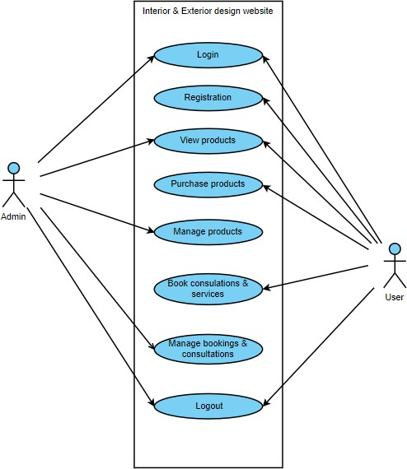

ACTIVITY DIAGRAMS

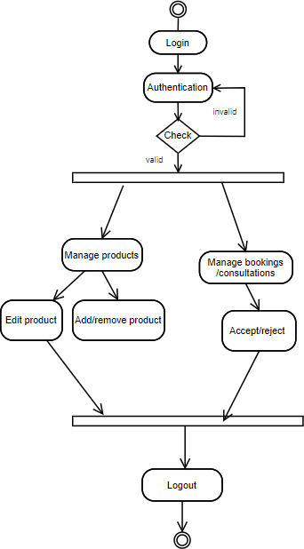
ADMIN SIDE

USER SIDE

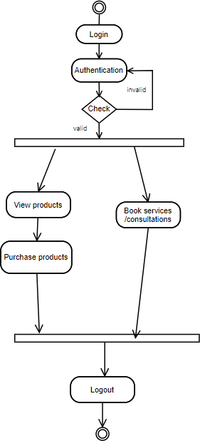

  - MODULE DETAILS

There are eight main modules in this website:

➢ Login Module
➢ Registration Module
➢ Service Management Module
➢ Booking Management Module
➢ Vehicle Management Module
➢ Staff Management Module
➢ Communication Module
➢ Admin Dashboard Module

Login Module

The login module allows registered users (customers, staff, and administrators) to securely access
the Car Service Management System. It verifies user credentials (email and password) to grant
access to role-specific functionalities such as booking services, managing schedules, and
overseeing operations.

Registration Module

The registration module enables new customers to create accounts on the platform. Users provide
personal details including name, email, phone number, and password to register and access
features like vehicle management, service booking, and communication with staff.

Service Management Module

The service management module allows customers to browse available automotive services and
admins to manage the service catalog. Customers can view detailed service information including
descriptions, pricing, and estimated time, while admins can add, edit, or remove services

Booking Management Module

The consultation booking module enables users to schedule virtual or in-person consultations with design experts through Celestia and receive confirmation of their consultation bookings.

Vehicle Management Module

The vehicle management module allows customers to register and manage their vehicle information
including type, brand, model, registration number, and year. Multiple vehicles can be associated
with a single customer account for convenient service booking.

- Staff Management Module

The staff management module provides functionality for staff members to manage their work
schedules, apply for leave, and track their assignments. Admins can manage staff accounts,
approve leave applications, and monitor staff performance.

7. Communication Module

The communication module facilitates messaging between customers and staff members. Customers
can send inquiries or support requests, while staff can respond to customer messages and provide
assistance throughout the service process.

- Admin Dashboard Module

The admin dashboard module provides administrators with comprehensive tools to oversee all
system operations including booking management, staff coordination, service catalog management,
and business analytics. Admins can ensure smooth platform operation and maintain data integrity.

  - PERFORMANCE CONSIDERATIONS

Hardware Requirements

The system is designed to perform optimally with a minimum of 4GB RAM and is compatible
with Windows OS versions and higher. The web-based nature ensures accessibility across various
devices and operating systems.

  - SECURITY CONSIDERATIONS

Access Control

- Authorized Access: Only users with valid email addresses and passwords are allowed to access the Car Service Management System.
- Role-based Security: The system implements role-based access control ensuring customers,staff, and admins only access appropriate functionalities.
. Data Protection: All sensitive information including customer data and vehicle information

  - TABLE DESIGN

1.Table name: user

Sl.no | Field Name | Data Type | Constraint | Description
1. | uid | int(11) | Primary Key,  Auto_increment, Not null | Customer User id
2. | ufname | varchar(30) | Not null | Name of the customer
3. | ulname | email varchar(50) | Not null | Last name of the  user
4. | uphone | bigint(10) | Unique Key,  Not null | Phone number of  the user
5. | upass | varchar(255) | Not null | Password of the  user
6. | udob | date | Not null | Date of birth of  the user

7. | uemail | varchar(100) | Unique Key,  Not null | Email of the user
8. | role | Int(11) | Default 2 | Role specifying  user or admin

Table name: products

Sl.no | Field Name | Data Type | Constraint | Description
1. | pid | int(11) | Primary key, Auto_increment,  Not null | Product id
2. | pname | varchar(255) | Not null | Product name
3. | price | decimal | Not null | Product price
4. | pimage | varchar(255) | Not null | Product image
5. | deleted | tinyint(1) | Yes, Default 0 | Shows whether deleted or not

Table name: consultations

Sl.no | Field Name | Data Type | Constraint | Description
1. | id | int(11) | Primary key, Auto_increment,  Not null | Consultation id
2. | name | int(11) | Foreign key,  Not null | User id from  user table
3. | email | varchar(255) | Not null | Type of  designer
4, | phone | varchar(20) | Not null | Phone no. of user
5. | consultation_type | Enum(‘in_person’,’virtual’) | Not null | Type of  consulation
6. | preferred_date | date | Not null | Date of  consultation
7. | Preferred_Time | time | Not null | Time of consultation
8. | status | enum | Yes null | Status of consultation

9. | Created_at | timestamp | Not null | Time of creation

Table name: orders

Sl.no | Field Name | Data Type | Constraint | Description
1. | Order_id | int(11) | Primary key, Auto_increment,  Not null | Order id
2. | User_id | int(11) | Foreign key,  Not null | User id from user  table
3. | Product_id | Int(11) | Foreign Key,  Not null | Product id from  products table
4. | quantity | Int(11) | Not null | Quantity of  products
5. | Order_Date | datetime | Yes null, Current_Time | Date and time ordered
6. | status | Varchar(50) | Not null | Status of order

Table name: bank

Sl.no | Field Name | Data Type | Constraint | Description
1. | bid | int(11) | Primary key,  Auto_increment, Not null | Bank id
2. | cvv | int(3) | Not null | CVV number of  card
3. | bno | Bigint(!1) | Not null | Bank Account  Number
4. | bbal | int(10) | Not null | Bank Account  balance

Table name: accountholder

Sl.no | Field Name | Data Type | Constraint | Description
1. | holder_id | int(11) | Primary key,  Auto_increment, Not null | Bank Account holder id
2. | bid | Int(11) | Default null | Bank id foreign key from bank  table
3. | bfname | Varchar(255) | Default null | Accunt holder  first name
4. | blname | Varchar(255) | Default null | Account holder last name

Table name: bookings

Sl.no | Field Name | Data Type | Constraint | Description
1. | Booking_id | int(11) | Primary key,  Auto_increment, Not null | Booking id of service
2. | Userid | int(11) | Foreign key,  Not null | User id from  user table
3. | Service_name | Varchar(255) | Not null | Service name
4. | Customer_name | Varchar(255) | Not null | Name of  customer
5. | Customer_email | Varchar(255) | Not null | Email of  customer
6. | Book_date | date | Not null | Booking date
7. | Created_at | timestamp | Not null, Default current_timestamp() | Time of  booking
8. | status | enum | Not null, Default pending | Status of booking

Table name: cart

Sl.no | Field Name | Data Type | Constraint | Description
1. | cid | int(11) | Primary key,  Auto_increment, Not null | Cart id
2. | pid | Int(11) | Not null | Product id foreign key from  products table
3. | uid | Int(11) | Not null | User id foreign key from user  table
4. | price | Decimal(10,2) | Not null | Price of product
5. | quantity | Int(2) | Not null, Default 1 | Quantity of product

Table name: contact

Sl.no | Field Name | Data Type | Constraint | Description
1. | id | int(11) | Primary key,  Auto_increment, Not null | Contact id
2. | name | Varchar(255) | Not null | Name of the  customer
3. | email | Varchar(255) | Not null | Customer  email
4. | message | text | Not null | Contact message
5. | status | Enum(‘unread’,’read’) | Yes null, Default unread | Status of message
6. | Date_Recieved | timestamp | Not null. Default current_timestamp() | Date message receieved

CODING

- CODING

  - INTRODUCTION

Coding section is where the magic happens. All the planning and the designing done in the previous sections come to life in this section. After this section can only the programmer enjoy the result of his/her hard work when he/she runs the program for the first time.

  - SELECTION OF SOFTWARE

PHP
PHP, an acronym for Hypertext Preprocessor, is a versatile server-side scripting language that
falls under the broader category of software development. It is widely recognized for its pivotal
role in web development and boasts several essential features that make it a preferred choice for
building dynamic websites and web applications. Here are some of its key features:

- open Source

- Database Integration

- Embedded in HTML

- Cross-Platform Compatibility

- Security

MYSQL

- MySQL is an open-source relational database system, widely used for web development tasks like data storage, manipulation, and retrieval. It seamlessly integrates into web applications, eliminating the need for complex setup. MySQL is embedded within web development environments, making administrative tasks effortless. It operates as an SQL-based database,storing data in structured tables. Unlike systems requiring complex configuration, MySQL simplifies data access with its broad range of relational database features. Its features are:

- Zero configuration

- Server less

- Less memory

- Self-contained

- Transactional

5.3 CODING PHASE

The goal of the coding or programming phase is to translate the design of the system
produced during the design phase into code in a given programming language, which can be executed by a computer and that performs the computation specified by the design. The coding phase affects both testing and maintenance profoundly.

The coding phase does not affect the structure of the system; it has great impact on the internal structure of modules, which affects the testability of the system. The goal of the coding phase is to produce clear simple programs. The aim is not to reduce the coding effort, but to program in a manner so that testing and maintenance costs are reduced.

Programs should not be constructed so that they are easy to write; they should be easy to read and understand. Reading programs is a much more common activity than writing programs. Hence, the goal of the coding phase is to produce simple programs that are clear to understand and modify.

CODING STANDARDS

The standard used in the development of the system is industry-standard PHP programming practices.
It includes naming conventions of variables, constants and objects, standardized formats for
labelling and commenting code, spacing, formatting and indenting.

Naming Conventions

The database tables and fields follow consistent naming patterns. Tables are named descriptively
(register, bookings, services, etc.), fields are prefixed appropriately (user_id, booking_id, etc.),
and relationships are clearly defined through foreign keys.

Labels and Comments

The functions of each module are clearly documented in the code. The database structure includes
comments and constraints so that other developers using the system in future might understand
the module functions better.

TESTING
& IMPLEMENTATION

TESTING

INTRODUCTION

Software testing is a critical element of software quality assurance and represents the ultimate
review of specifications design and coding. Testing presents an interesting anomaly for the
software engineer. Testing is a quality measure process, which reveals the errors in the program.
During testing, the program is executed with a set of test cases and the output of the program for
the test cases is evaluated to determine if the program is performing as it is expected. Testing
plays a very critical role in determining the reliability and efficiency of the software and it is a
very important stage in software development.

TESTING

System testing is actually a series of different tests whose primary purpose is to fully exercise the
computer-based systems. Although each test has a different purpose, all work to verify that all
system elements have been properly integrated and perform allocated functions.

System testing is done in order to ensure that the system developed doesn't fail at any point.
Before implementation, the system is tested with experimental data to ensure that it will meet
the specified requirements. Special test data are input for processing and results examined.

TEST PLAN

Preparation of test data

Testing of the Car Service Management System is done using various kinds of test data. Preparation
of test data plays a vital role in the system testing. After preparing the test data, the system
under study is tested using that test data. While testing the system by using test data, errors are
uncovered and corrected using testing steps and corrections are also noted for future use. Two
kinds of test data were collected and used:

Using live test data

Live test data are those that are actually extracted from real automotive service operations.
After the system is partially constructed, developers often ask service center staff to enter
a set of data from their normal activities. Then, the system developers use this data as a way
to partially test the system. Customer bookings, vehicle information, and service records
from actual operations are used for testing.

Using artificial test data

Artificial test data are created solely for test purposes, since they can be generated to test
all combinations of formats and values. In other words, the artificial data, which can
quickly be prepared by a data generating utility program, make possible the testing of all
logic and control paths through the program. The most effective test program uses artificial
test data generated by persons other than those who wrote the program.

In this project, invalid data was entered to test whether the program would break or not.
These invalid data entries included incorrect email formats, invalid vehicle registration
numbers, and improper date formats. Many people were given the software for testing.
They used various invalid inputs to test if every validation holds strong.

TESTING METHODS

Testing is generally done at two levels - testing of individual modules and testing of the entire
system. During system testing, the system is used experimentally to ensure that the software
does not fail, that is, that it will run according to its specifications and the results examined.
A limited number of users may be allowed to use the system so analysts can see whether they use
it in unforeseen ways. It is preferable to discover any surprises before the organization implements
the system and depends on it.

Testing is done throughout system development at various stages. It is always a good practice to
test the system at many different levels at various intervals, that is, sub systems, program
modules as work progresses and finally the system as a whole. During testing the major
activities are concentrated on the examination and modification of the source code. Usually, this
testing is to be performed by persons other than those who have coded it. This is done in order
to ensure more complete and unbiased testing for making the software more reliable.

There are two types of testing:

Black box testing
White box testing

WHITE BOX TESTING
In white box testing, the internal logic of the modules is considered. Following levels of testing are performed for the developed project:

Unit Testing

This involves the tests carried out on modules programs, which make up a system. This is also called as a program testing. The units in a large system many modules at different levels are needed. Unit testing focuses on the modules, independently of one another, to locate errors. The program should be tested for correctness of logic applied and should detect errors in coding. Before proceeding one must make sure that all the programs are working independently.

BLACK BOX TESTING
The concept of the black box is used to represent a system who’s inside workings are not available for inspection. In a black box, the test item is treated as “black”, since its logic is unknown; all that is known is what goes in and what comes out, or the input and output.

System Testing

The system testing is conducted on a complete, integrated system to evaluate the system’s compliance with its specified requirement. It falls within scope of black box testing so no knowledge of inner design or logic is needed. As a rule, system testing takes, as its input, all of the integrated software components that have passed integration testing and also the software system itself integrated with any applicable hardware system. The purpose of the integration testing is to detect any inconsistencies between software units.
System testing is the stage of implementation, which is aimed at ensuring that the system works accurately and efficiently before live operation commence. The logical design and the physical design should be thoroughly and continually examined on paper ensure that they will work when implemented.

Integration Testing
Integration testing is a systematic technique for constructing the program structure, while at the same time conducting tests to uncover errors associated with interfacing. This is the program is constructed and tested in small segments, which makes it easier to isolate and the following common types of integration problems may be observed:

        - Version mistakes

        - Data integrity violations

        - Overlapping function

        - Resource problems especially in memory handling

        - Wrong type of parameter in function calls

Validation Testing

At the culmination of the integration testing, the software was completely assembled as a package,
interfacing errors have been uncovered and corrected and a final series of software validation
testing began.

In validation testing we test the system functions in a manner that can be reasonably expected by
customers. The system was tested against system requirement specifications. Different unusual
inputs that the users may use were assumed and the outputs were verified for such unprecedented
inputs. Deviation or errors discovered at this step are corrected prior to the completion of this
project with the help of users by negotiating to establish a method for resolving deficiencies.
Thus, the proposed system under consideration has been tested by using validation testing and found
to be working satisfactorily. Validation checking is performed on:

Numeric Field: The numeric fields can contain only numbers from 0 to 9. Entry of any other
character displays an error message. Fields like phone numbers, vehicle years, and service prices
are validated.

Character Field: This field can only contain letters from A-Z and a-z. It is useful for name
fields, vehicle brands, and service descriptions.

Check Null Fields: Before entering values into the database or when updating, a validation is
done to check whether any NULL fields are present.

Email Fields: Email validation ensures proper email format with necessary validation checks.
All email entries are verified before storage.

Password Fields: Password validation ensures minimum security requirements are met. All
password fields are validated before storage.

Date Fields: Date validation ensures proper date formats for appointment booking and leave
applications.

Vehicle Registration: Registration number validation ensures proper format according to
regional standards.

OUTPUT TESTING

After performing validation tests, the next phase is output testing of the system, since no system

could be useful if it does not produce the desired output in the desired format. The format of

reports/outputs was generated and tested. Here output formats were considered in multiple ways:

on the display screen, in booking confirmations, and in service reports.

USER ACCEPTANCE TESTING
User acceptance testing of the system is the key factor for the success of the system. The system
under consideration was tested for user acceptance by keeping constant contact with the perspective
users of the system at the time of design, development and making changes whenever required. This
was done with regard to the following points:

Input screen design
Output design
Navigation flow
Functionality completeness

Users from each of the 3 user types (Admin, Staff, Customer) were selected for user acceptance
testing. The Admin was given the software for testing with admin credentials. Admin actions like
managing services, bookings, and staff were performed to see whether all details are entering into
the database and working properly as expected. The staff side was tested using staff credentials
to verify leave applications and customer communication features. The customer side was tested by
registering new customers and allowing them to book services, manage vehicles, and communicate with staff.

IMPLEMENTATION

Implementation is the stage of the project when the theoretical design is turned into a working
system. The implementation stage is a system project in its own right. It includes careful planning,
investigation of current system and its constraints on implementation, design of methods to
achieve the changeover, training of the staff in the changeover procedure and evaluation of the
changeover method.

The first task in implementation is planning - deciding on the methods and time scale to be adopted.
Once the planning has been completed, the major effort is to ensure that the programs in the system
are working properly when the users have been trained.

The complete system involving both computer and users can be executed effectively. Thus, clear
plans are prepared for the activities.

Successful implementation of the new system design is a critical phase in the system life cycle.
Implementation means the process of converting a new or a revised system design into an operational one.

MAINTENANCE
& ENHANCEMENT

MAINTENANCE AND ENHANCEMENT

MAINTENANCE
This software can be modified as needs occur. Maintenance includes all the activities after
installation of the software that are performed to keep the system operational. The process of
maintenance involves:

➢ Understanding the existing software
➢ Understanding the effect of changes
➢ Testing for satisfaction

This software requires minimal maintenance. During the testing phase, most maintenance duties
are performed. If a maintenance requirement occurs, it can be solved with ease due to the modular
architecture and well-documented code structure.

ENHANCEMENT

The Car Service Management System is built with a modular architecture, allowing for easy expansion and additional functionalities. As the automotive service business grows and customer demands evolve, the platform can seamlessly integrate new features to enhance the user experience.

Future enhancements to the Car Service Management System could include:

Mobile Application: Develop native mobile apps for Android and iOS platforms, allowing
customers to book services, track progress, and communicate with staff on-the-go.

Real-time GPS Tracking: Integrate GPS tracking for service vehicles, allowing customers
to track the arrival of mechanics for on-site services.

Payment Gateway Integration: Implement online payment processing to allow customers to
pay for services directly through the platform using credit cards, digital wallets, or
other payment methods.

Service Reminder System: Implement automated reminders for regular maintenance services
based on vehicle mileage, time intervals, or manufacturer recommendations.

Inventory Management: Add inventory tracking for spare parts and consumables, with
automatic reorder points and supplier management.

Customer Feedback System: Implement a comprehensive feedback system allowing customers
to rate services and provide reviews, helping maintain service quality.

Advanced Reporting: Develop detailed analytics and reporting features for business
intelligence, including revenue tracking, customer behavior analysis, and operational
efficiency metrics.

Multi-location Support: Extend the system to support multiple service center locations
with centralized management and location-specific operations.

AI-powered Service Recommendations: Implement machine learning algorithms to suggest
appropriate services based on vehicle history, age, and usage patterns.

Integration with OEM Systems: Connect with vehicle manufacturer systems for warranty
information, recalls, and technical service bulletins.

These future developments will help enhance the Car Service Management System's offerings,
attract new customers, and provide a seamless, comprehensive experience that stays competitive
as technology advances in the automotive service industry.

CONCLUSION

CONCLUSION

In today's rapidly evolving automotive service industry, technology plays a pivotal role in shaping customer experiences and optimizing service delivery. Traditional methods of managing automotive services are being transformed by innovative digital solutions.
The Car Service Management System exemplifies this evolution, providing a comprehensive platform that bridges the gap between customers and service providers. With a user-friendly, integrated system, the platform harnesses modern web technologies to allow customers to book services,track vehicle maintenance, and communicate with service professionals seamlessly, eliminating the inefficiencies of traditional manual processes.
The primary goal of the Car Service Management System has always been to empower customers with easy access to high-quality automotive services while enabling service centers to operate more efficiently. The system streamlines service booking, enhances transparency through real-time status updates, and fosters trust within the automotive service community by providing reliable and accountable service management.

The system successfully addresses the key challenges faced in automotive service management:
scheduling conflicts, inefficient communication, lack of service tracking, and manual record
keeping. By digitizing these processes, the platform has significantly improved operational
efficiency, customer satisfaction, and business growth potential.

Key achievements of the system include:

➢ Streamlined booking process reducing scheduling conflicts
➢ Improved customer communication through integrated messaging
➢ Enhanced service tracking and transparency
➢ Efficient staff and resource management
➢ Comprehensive reporting and analytics capabilities
➢ Scalable architecture supporting business growth

As the automotive service industry continues to evolve, the Car Service Management System remains
committed to further enhancements, embracing new technologies such as mobile applications, IoT
integration, and artificial intelligence to meet the growing needs of both customers and service
providers. Looking ahead, the system aims to continue revolutionizing automotive service delivery
by integrating cutting-edge technology with traditional service excellence to create even more
seamless and impactful customer experiences.

The successful implementation of this system demonstrates the potential of digital transformation
in the automotive service sector, setting a foundation for future innovations and improvements
in customer service delivery.

BIBLIOGRAPHY

BIBLIOGRAPHY

WEBSITES
- Chatgpt

- www.wikipedia.org

- www.tutorialpoint.com

- www.pinterest.com

- www.pexels.com

- www.w3schools.com

APPENDIX

SCREENSHOTS

LOGIN PAGE

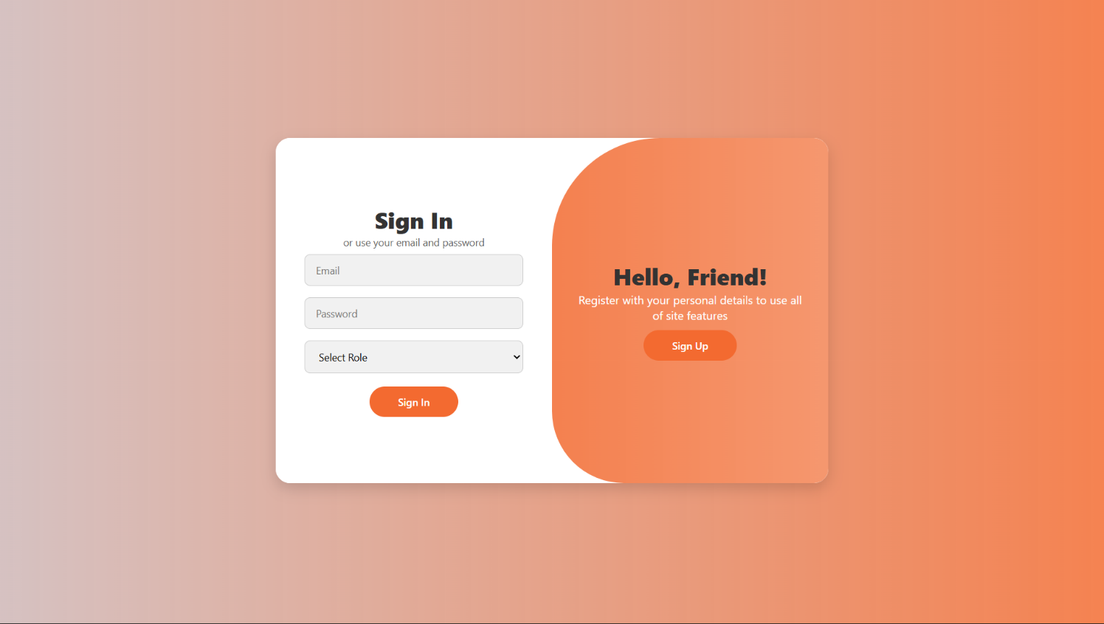

REGISTRATION PAGE
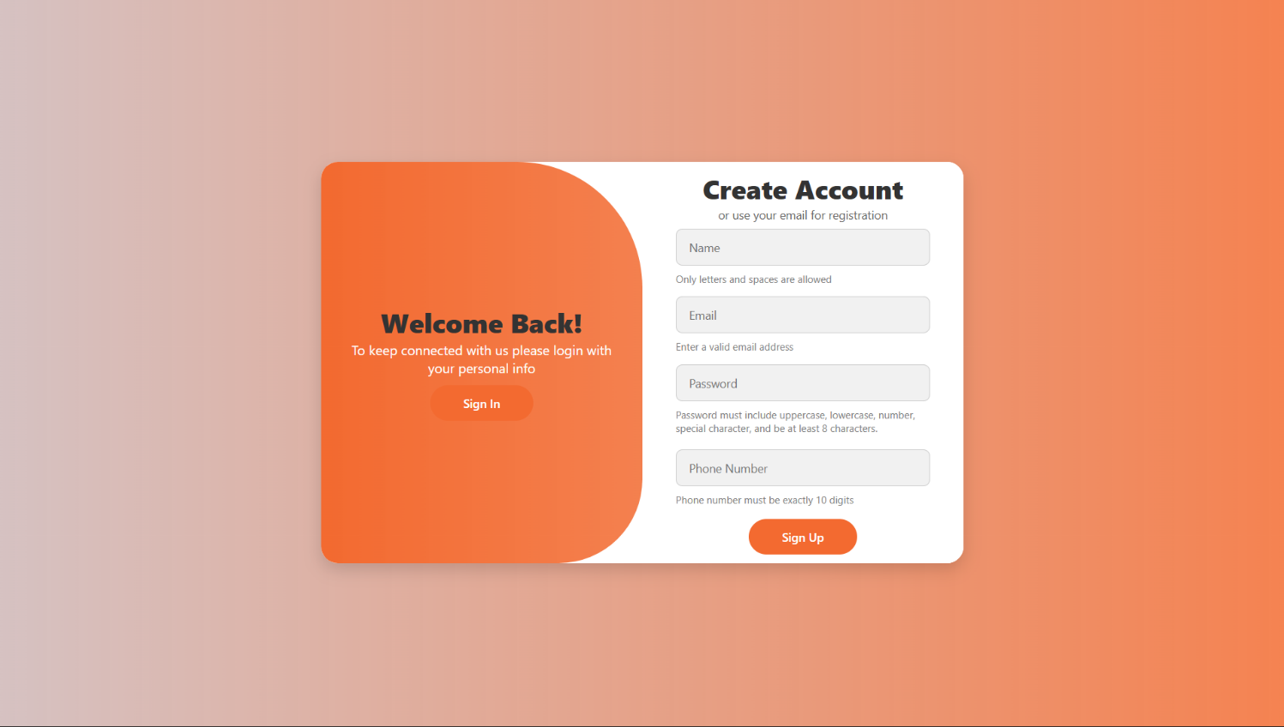

HOME PAGE

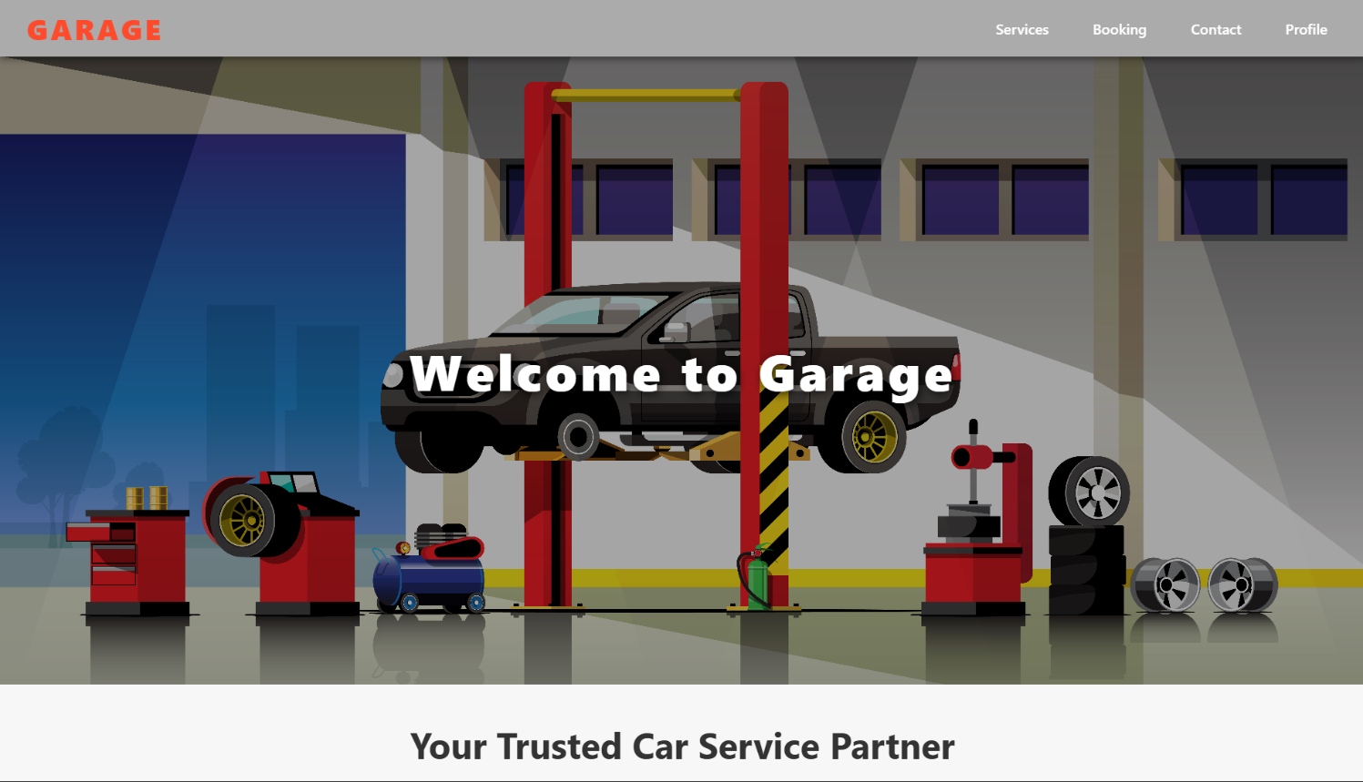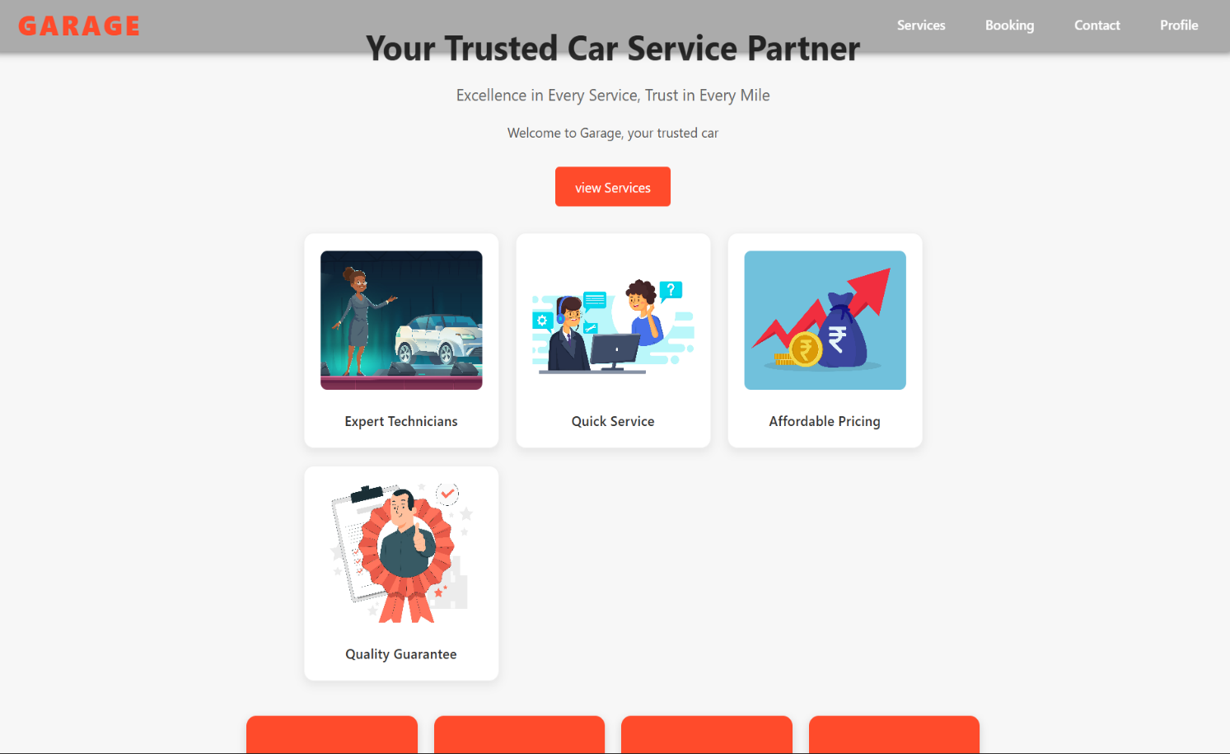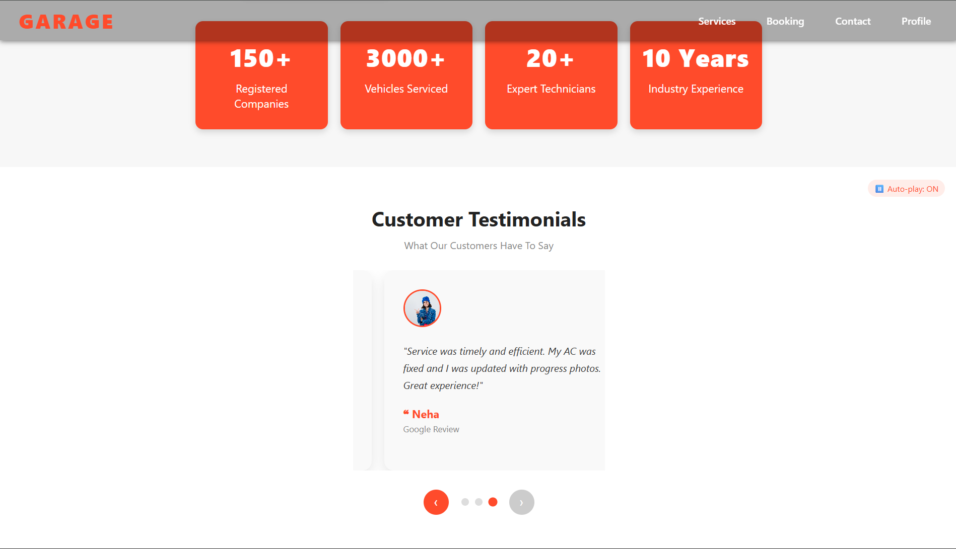



SERVICES PAGE

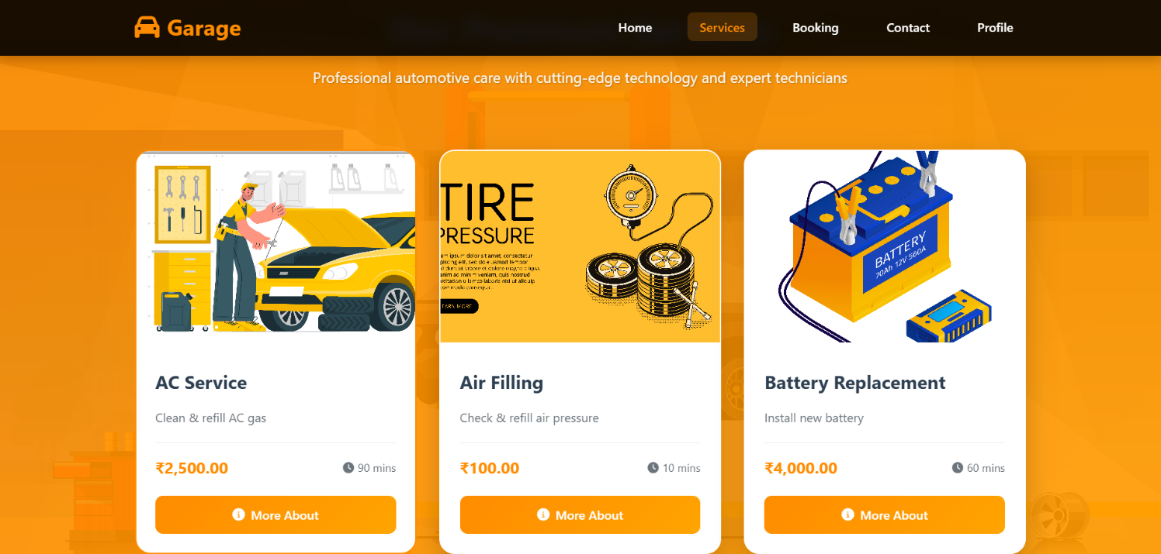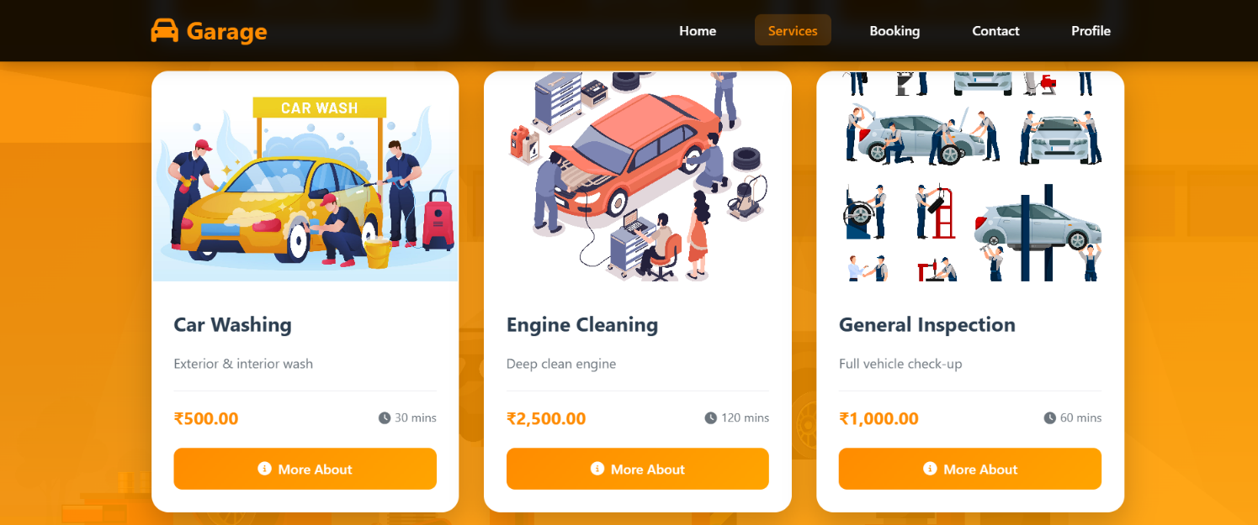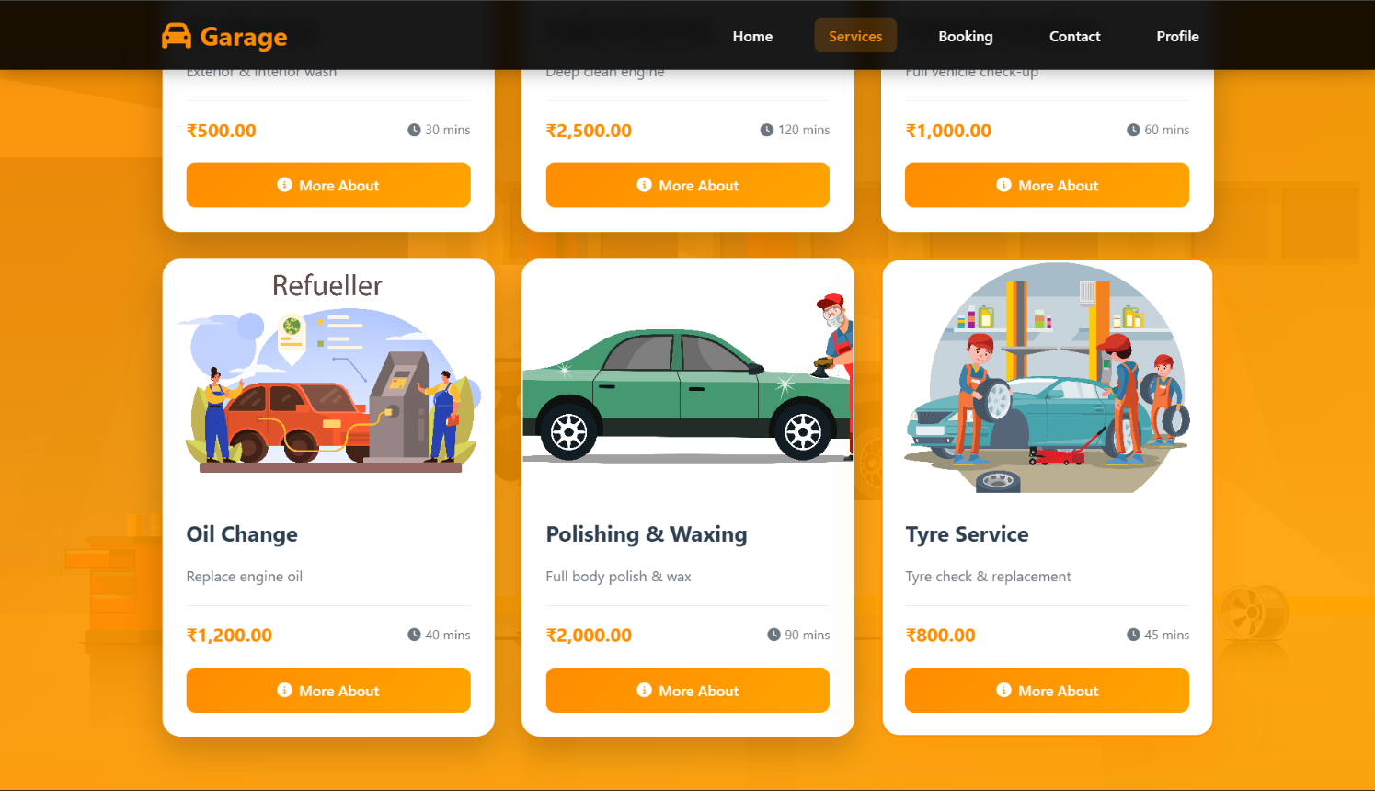

SERVICE BOOKING PAGE
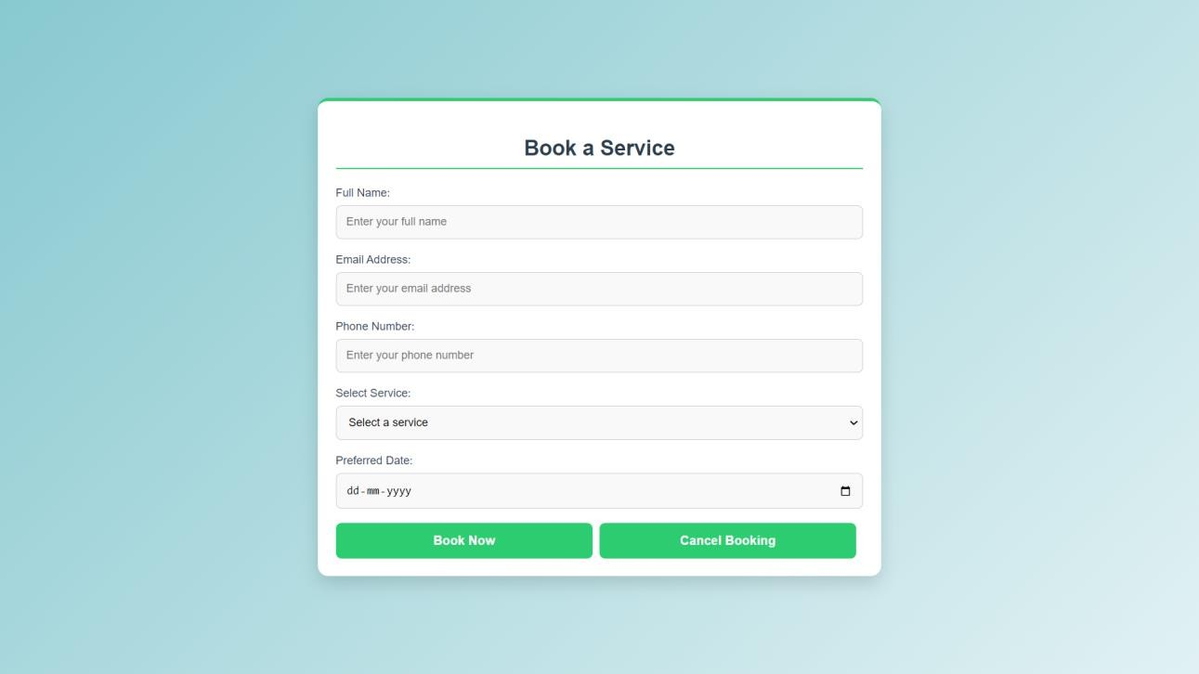

SHOP PAGE
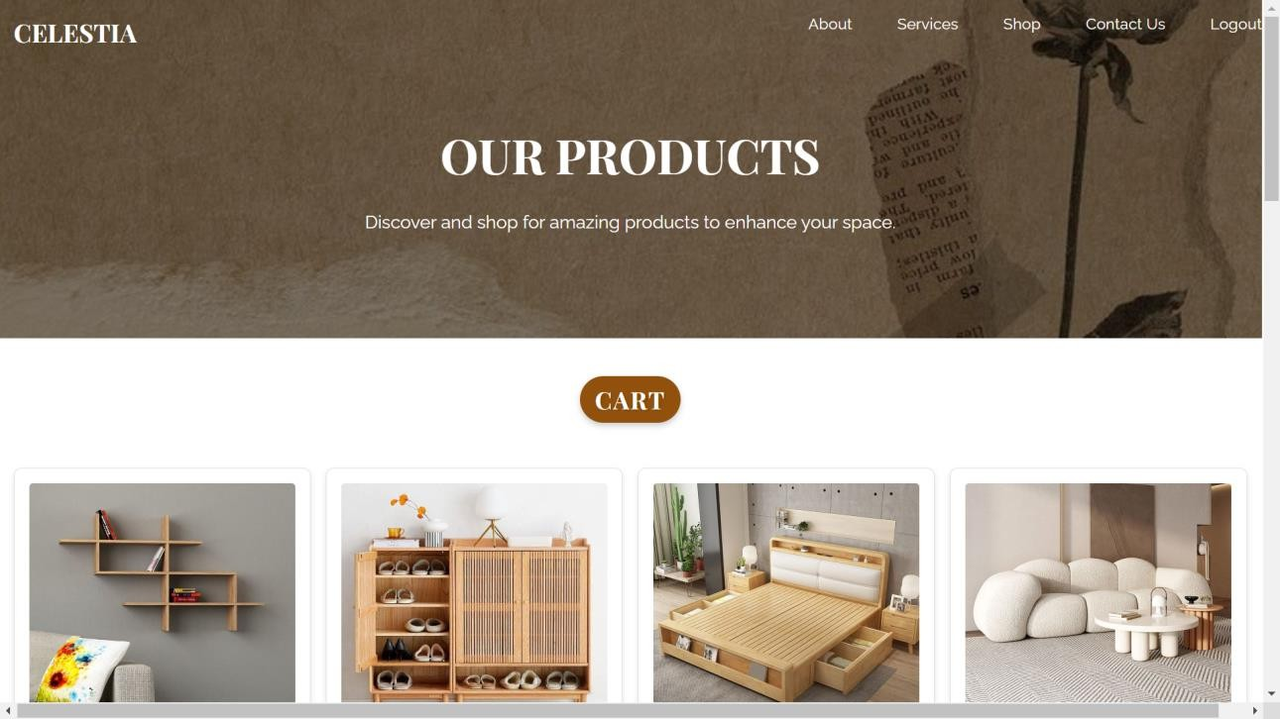



CART PAGE
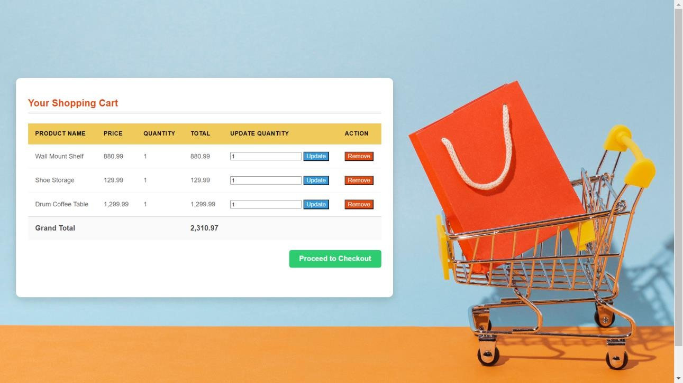

PAYMENT PAGE
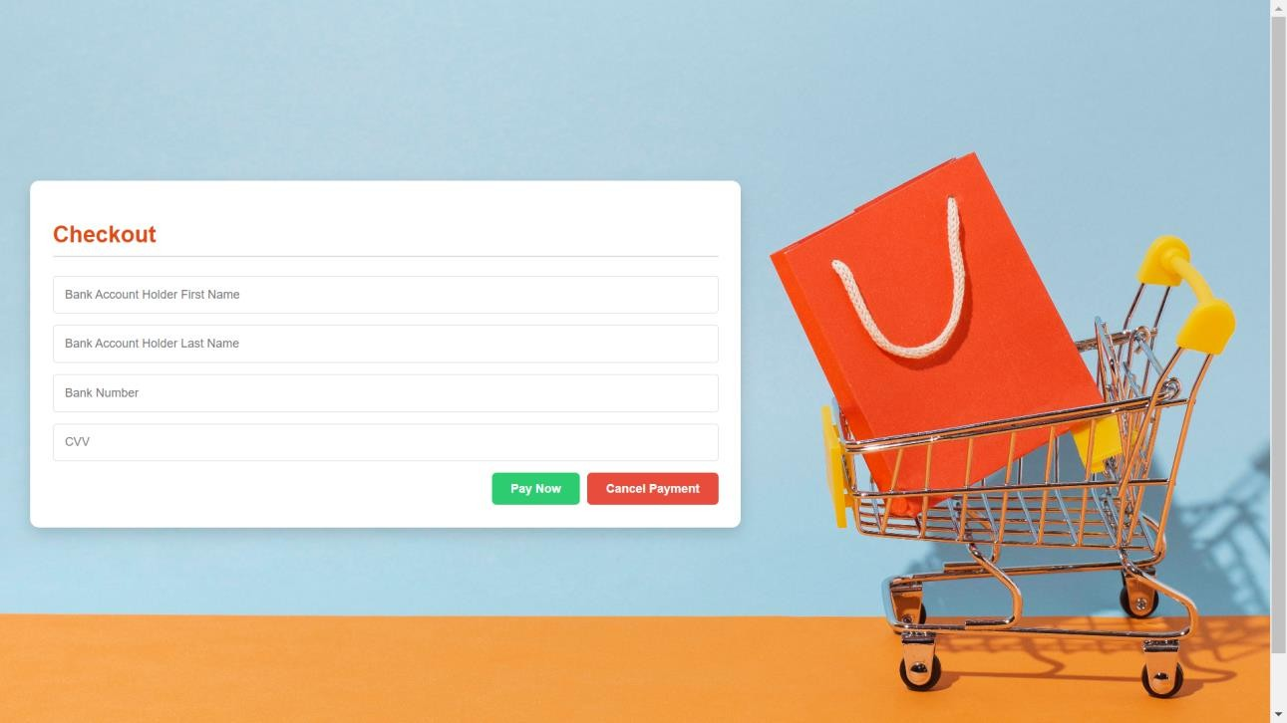

CONTACT PAGE
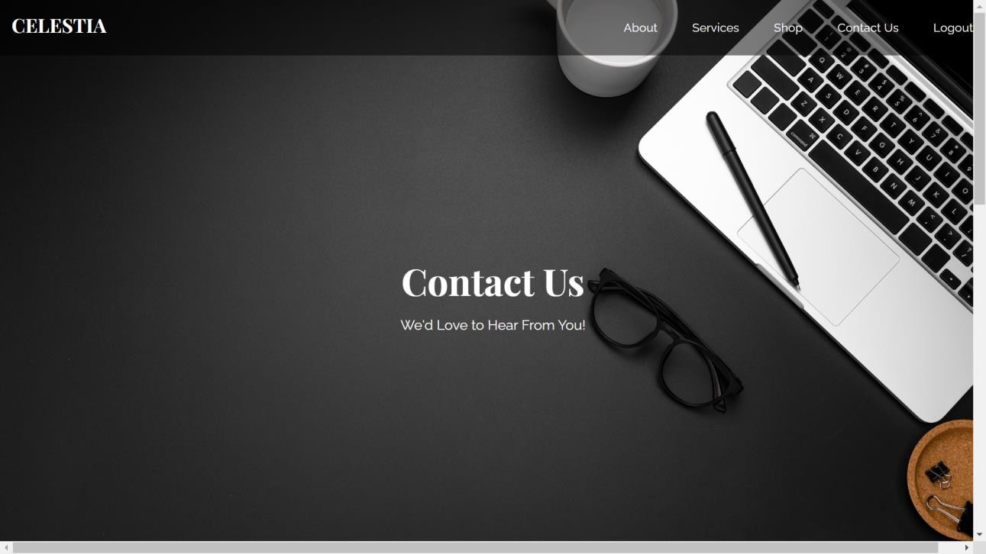

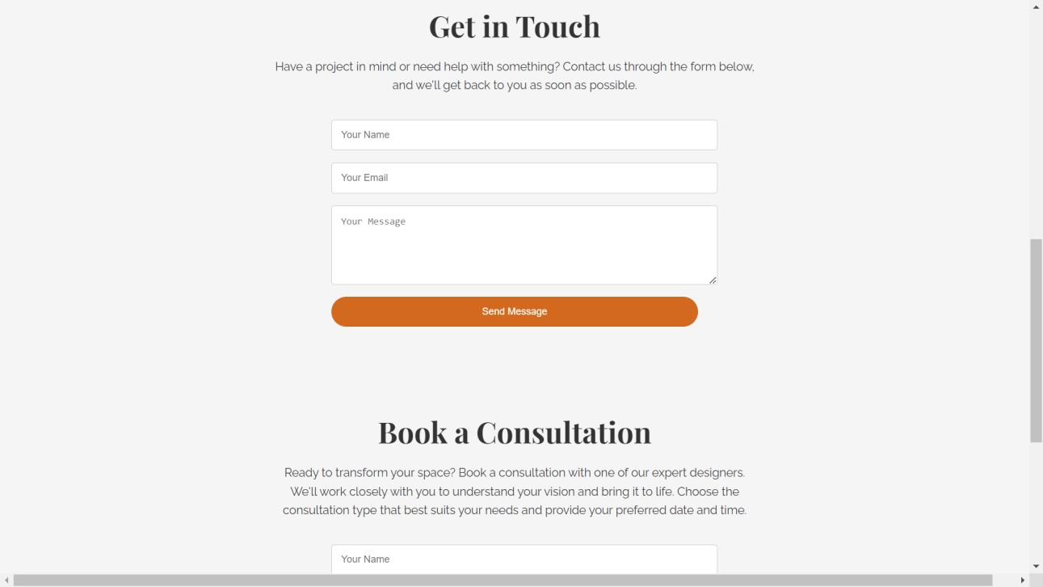

ADMIN MODULE

DASHBOARD PAGE
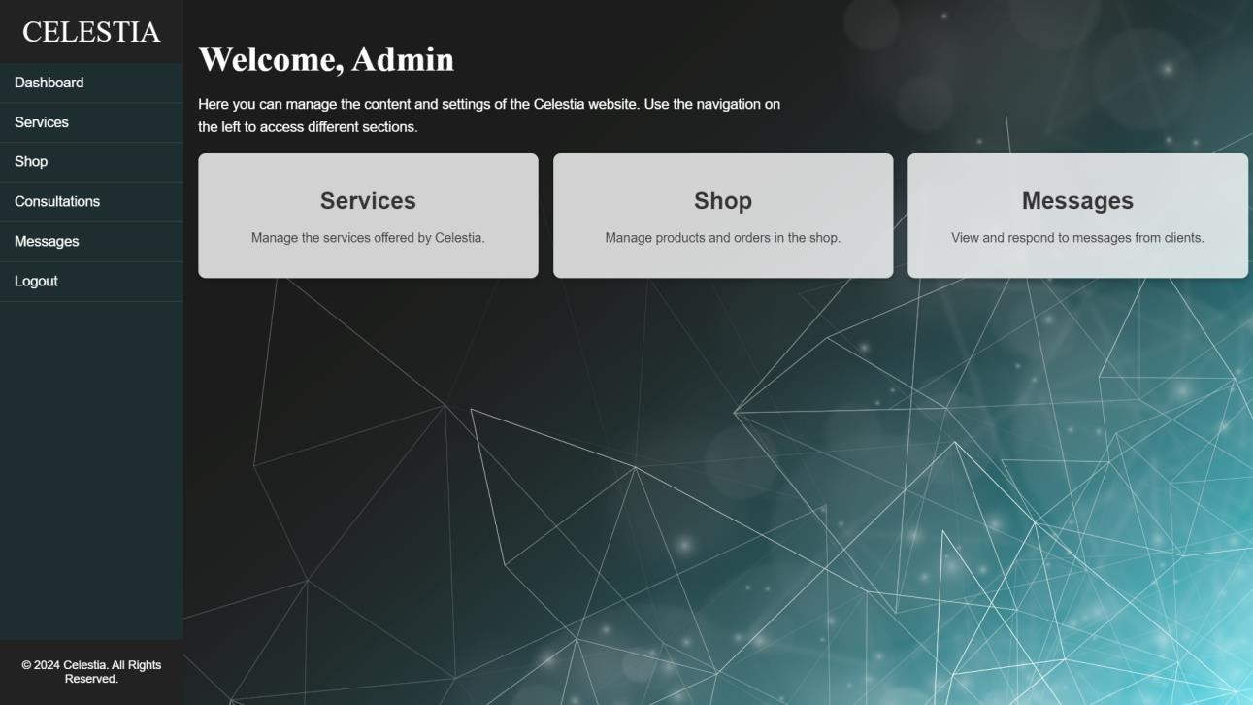

MANAGE SHOP PAGE
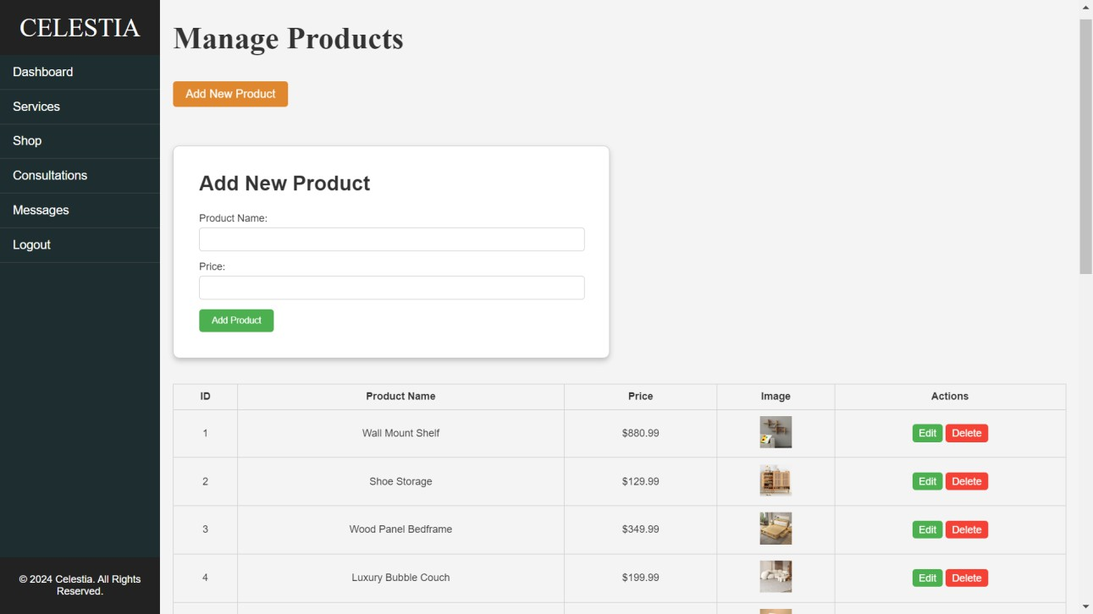

MANAGE CONSULTATIONS PAGE
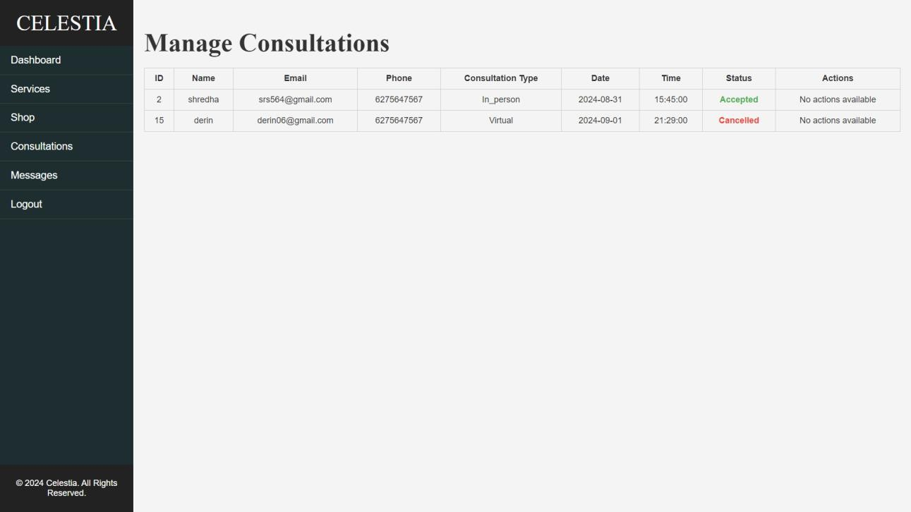

MANAGE MESSAGES PAGE
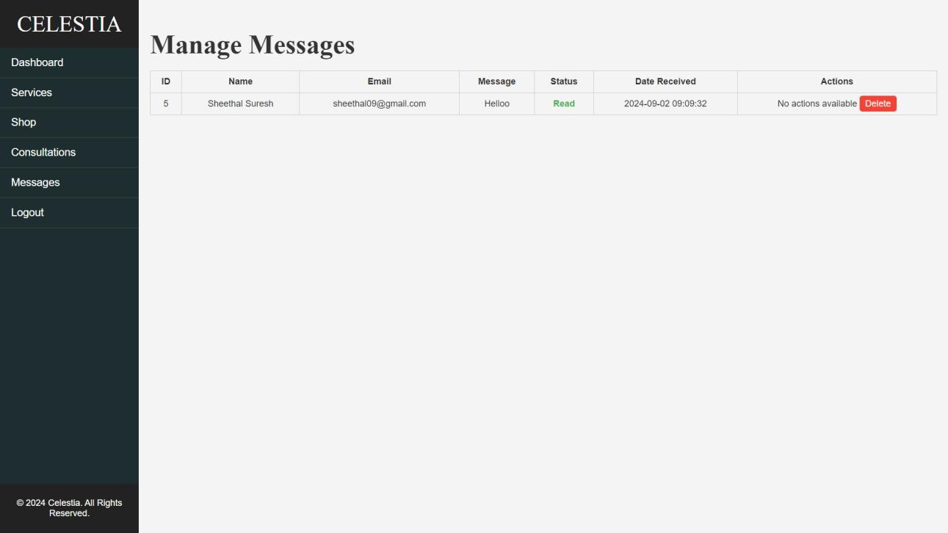

MANAGE SERVICES PAGE
